Site Design

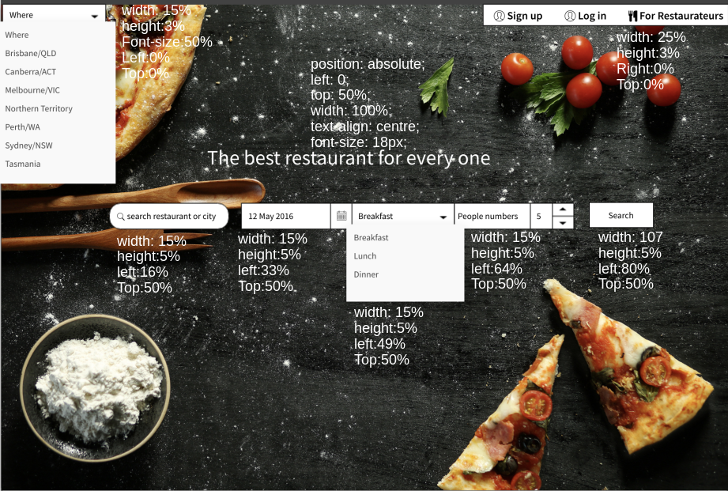

1. HomePage

Here’s our basic design for homepage, which allow us to find the best restaurant for customer. The left-top corner is to set the city, which has 8 options in Australia. The right-top corner is for user and restaurateurs to login and sign up in our webpage. In the centre of of homepage, we have search box, which allows us to find something nearby or text specific area. And then, we are supposed to choose the booking time and people numbers . After select those options, we can click the search button and we are going to search page.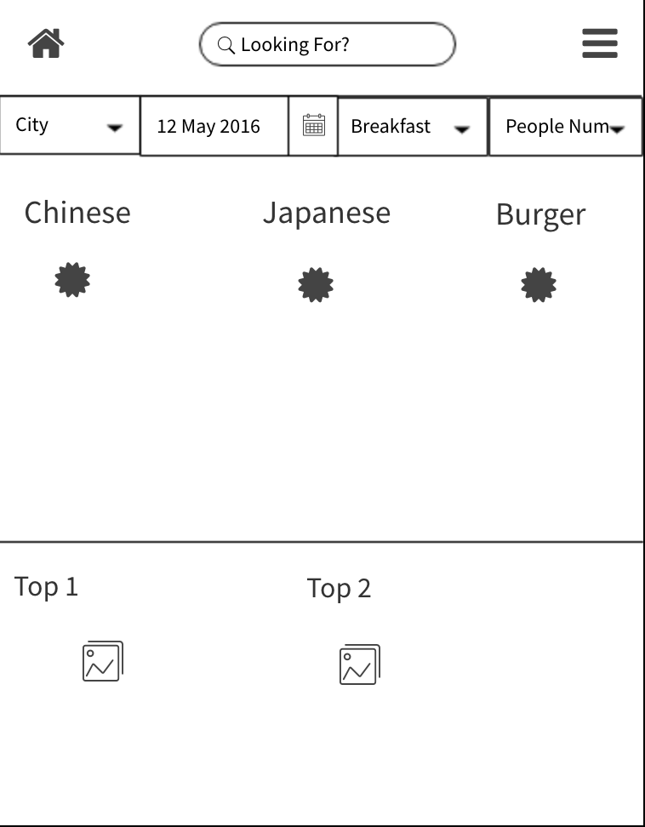

(we have comparison of mobile design on the right)

2. Login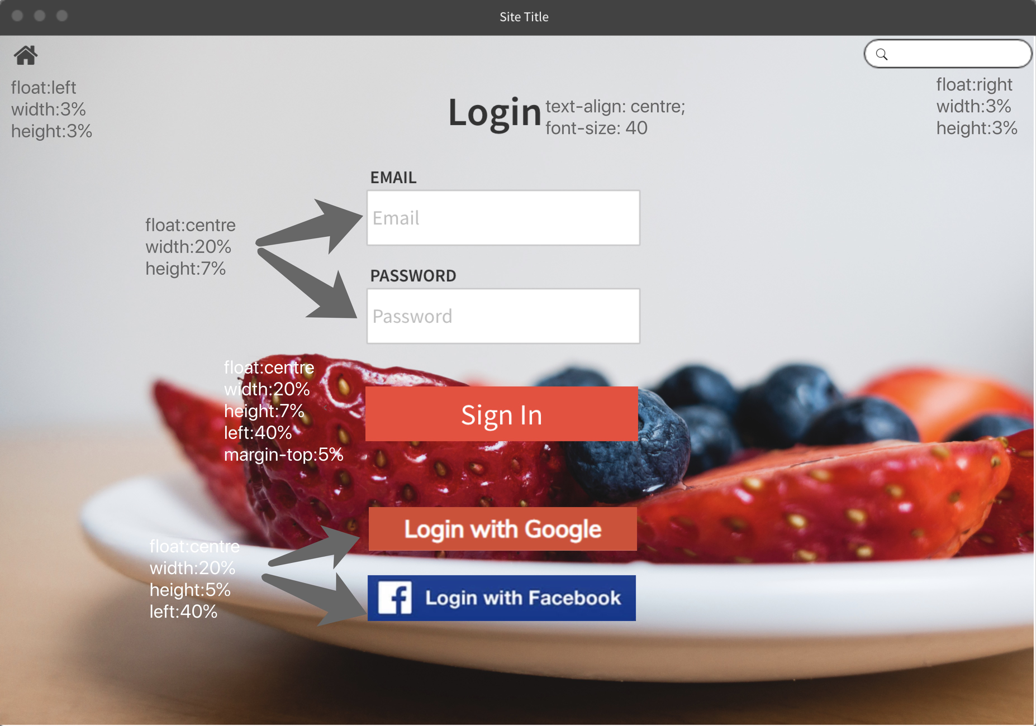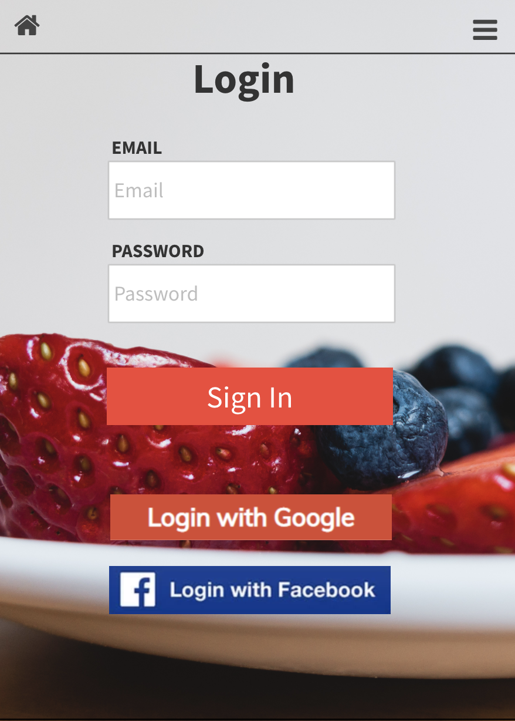

Here’s our login page, we have several buttons and text areas to help us to easily to login us webpage. The left-top button helps us to return to the homepage. And the right-top button helps us to search what we want to know. In the main of the login page, we need to type our email and password. Besides, we have third-party link to Google and Facebook, which is an easier way to sign in the webpage. After we click the sign in button we are going back to the homepage.

3. Sign up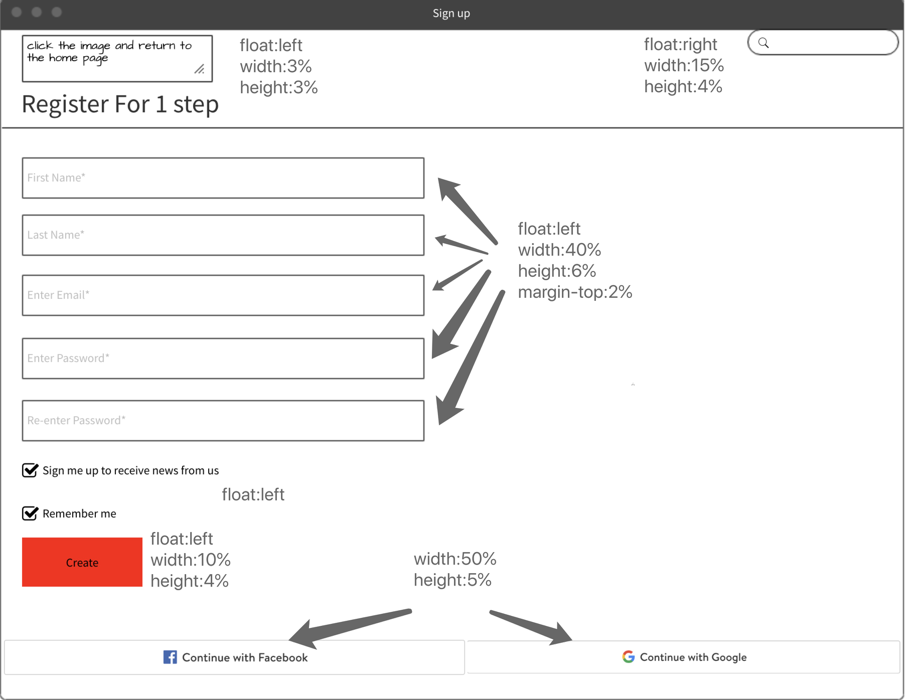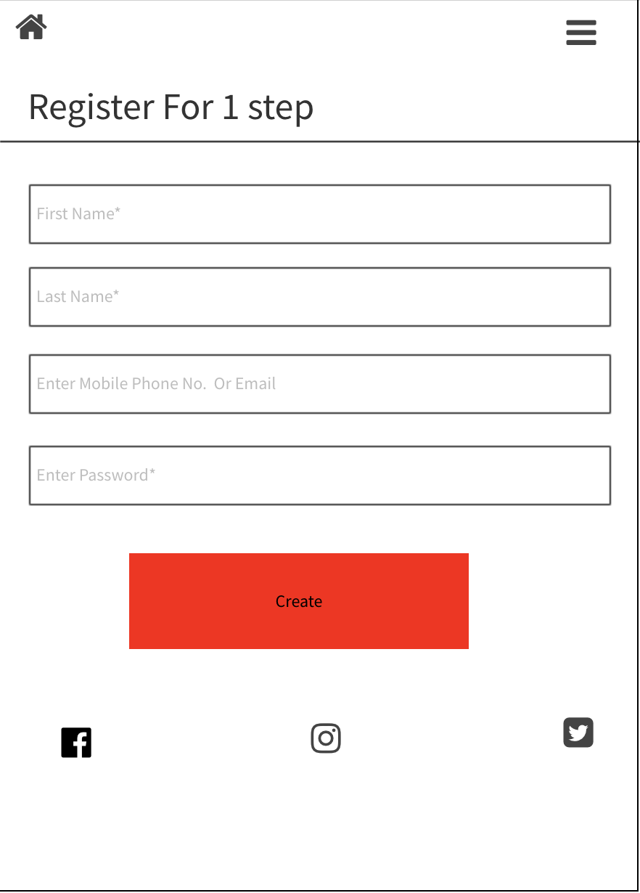

Here’s our design for sign-up page.In our every main pages, The left-top button helps us to return to the homepage. And the right-top button helps us to search what we want to know. We have several steps to create our account, which is typing our name, enter the email and set up password. Beside, we have third-party account to easily create an account of our page.

(we have comparison of mobile design on the right)

4. User management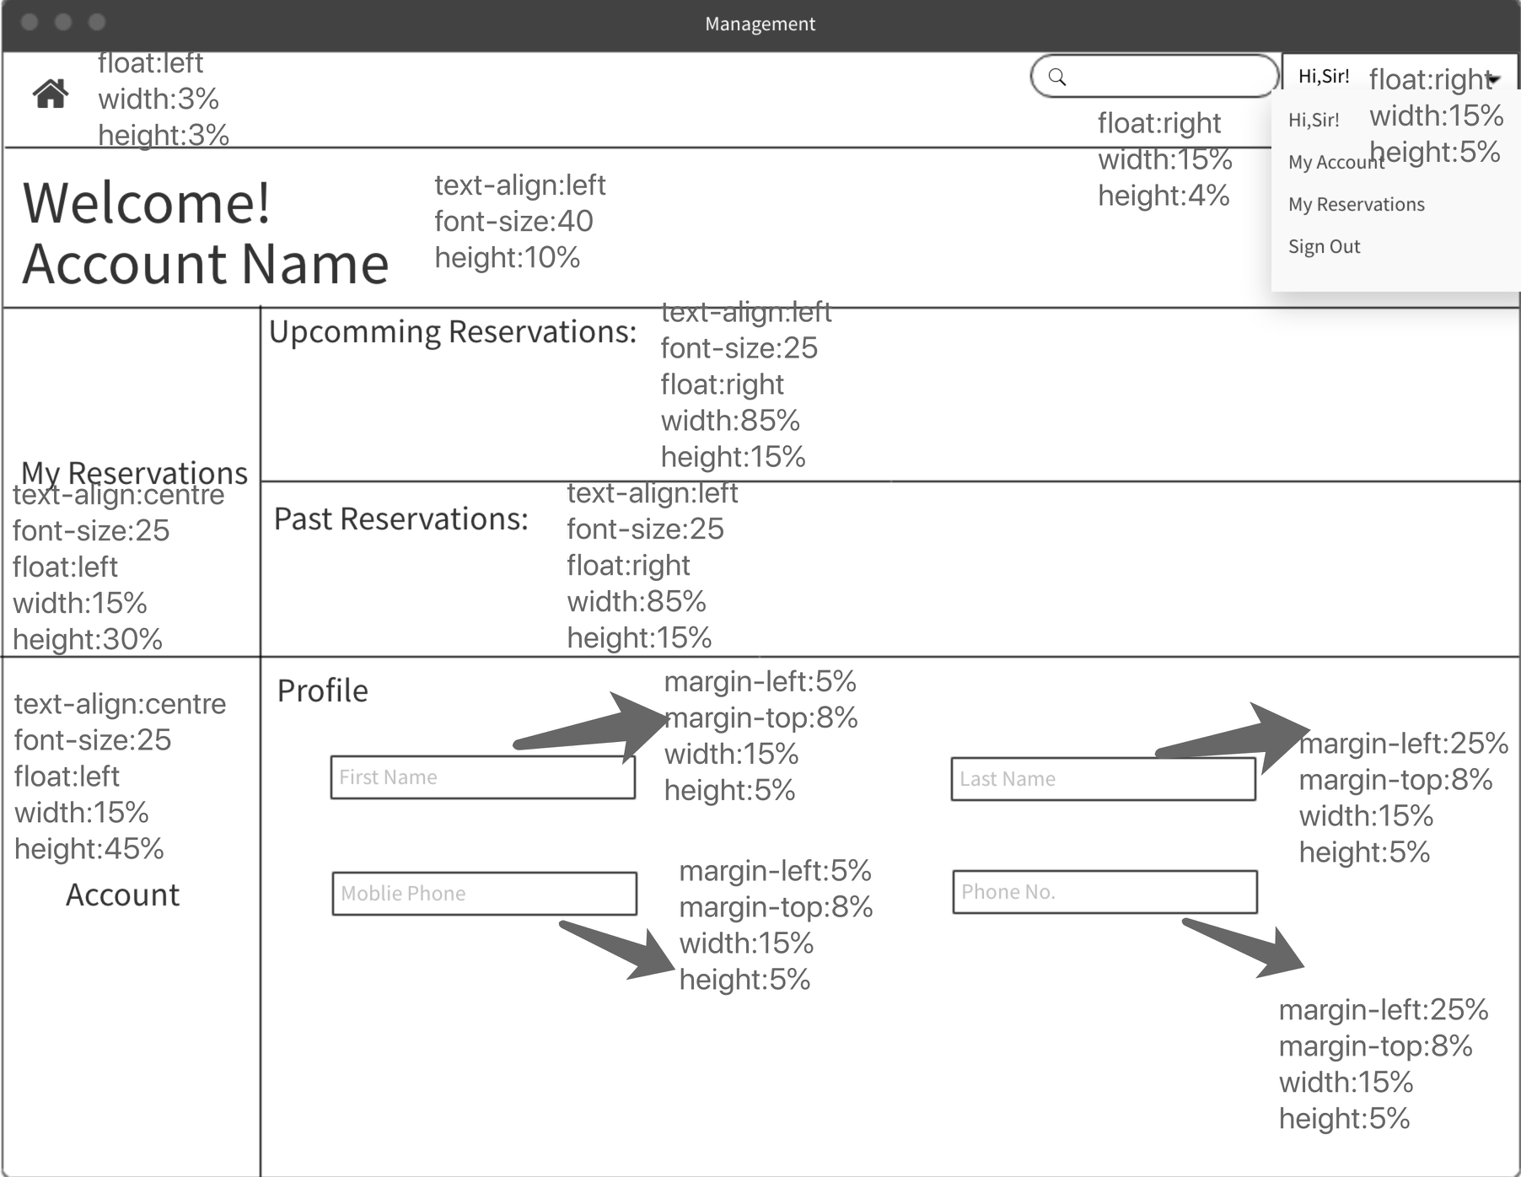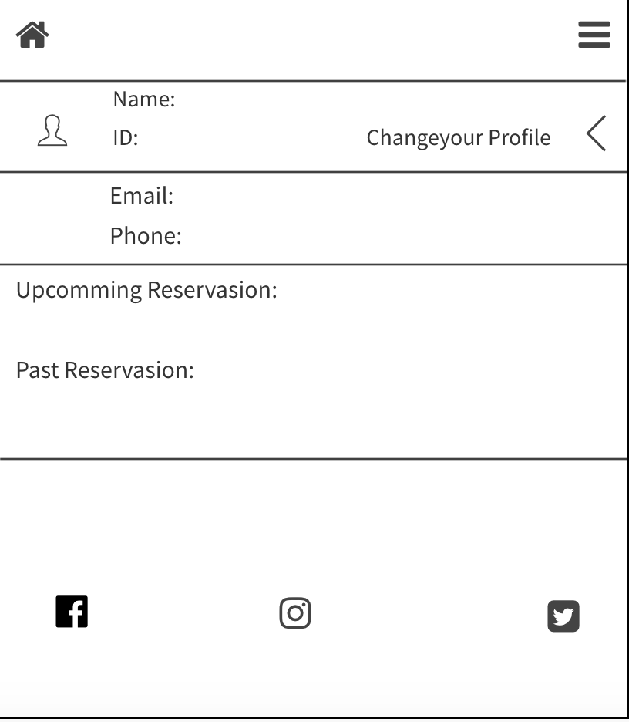

Here’s our user management, which allows users to check their reservations and re-set their basic information like name, phone number. On the right-top, we have a drop-down box which has sign out button to help user to leave the page.(we have comparison of mobile design on the right)

5. Restaurant Management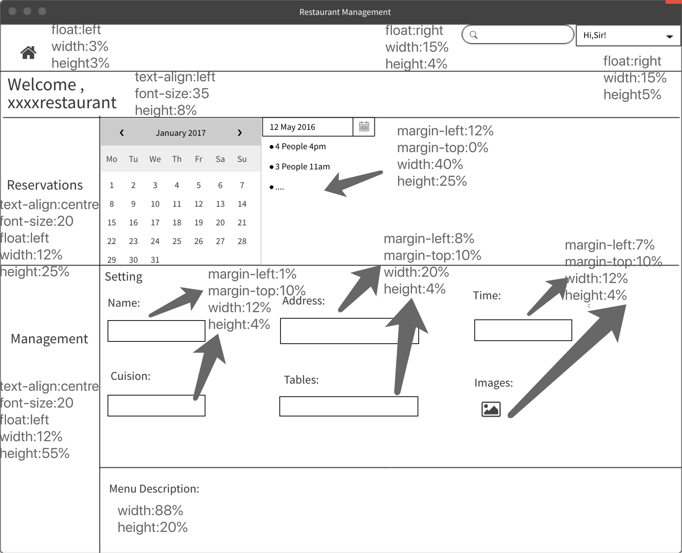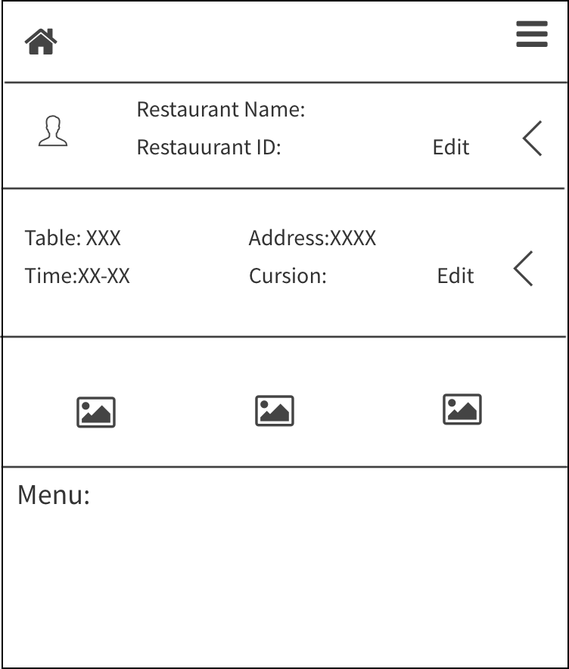

Here is our design for Restaurant Management, which allow restaurateurs to check customer’s reservation and manage the basic information of restaurant link menu, name ,address…etcOn the right-top, we have a drop-down box which has sign out button to help restaurateurs to leave the page.(we have comparison of mobile design on the right)

6. Search Page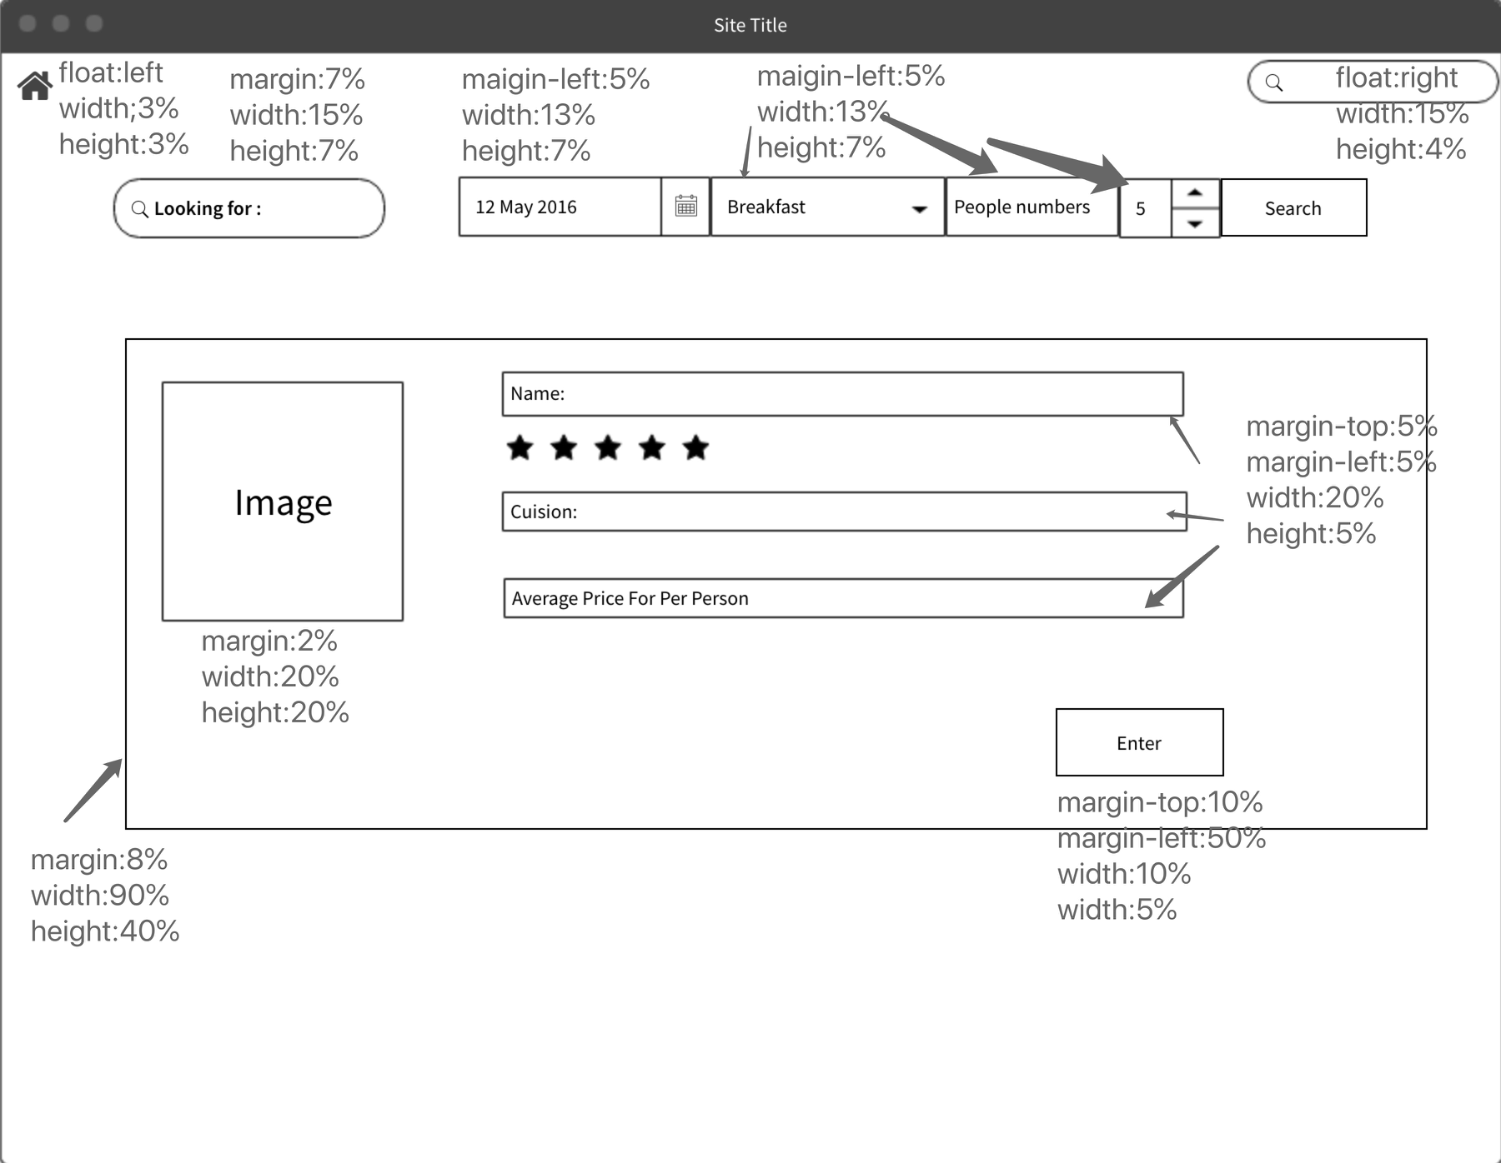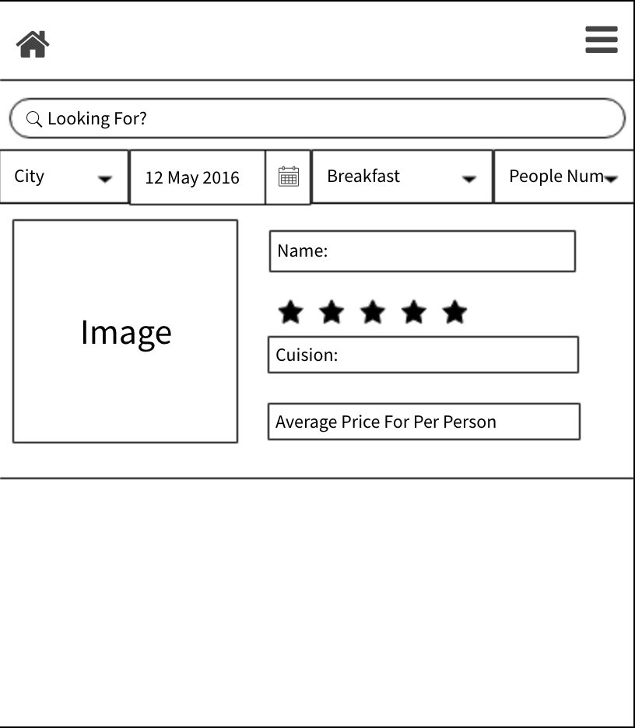

Here’s out design for Search page. The left-top search box helps costumer to choose another area restaurant.On the right, same options to choose and search new restaurant with new options. And in the centre we have the basic information of the each restaurant which includes review stars , name, cuisine, and average price.And we can see more information by clicking the enter button.(we have comparison of mobile design on the right)

7. Restaurant Page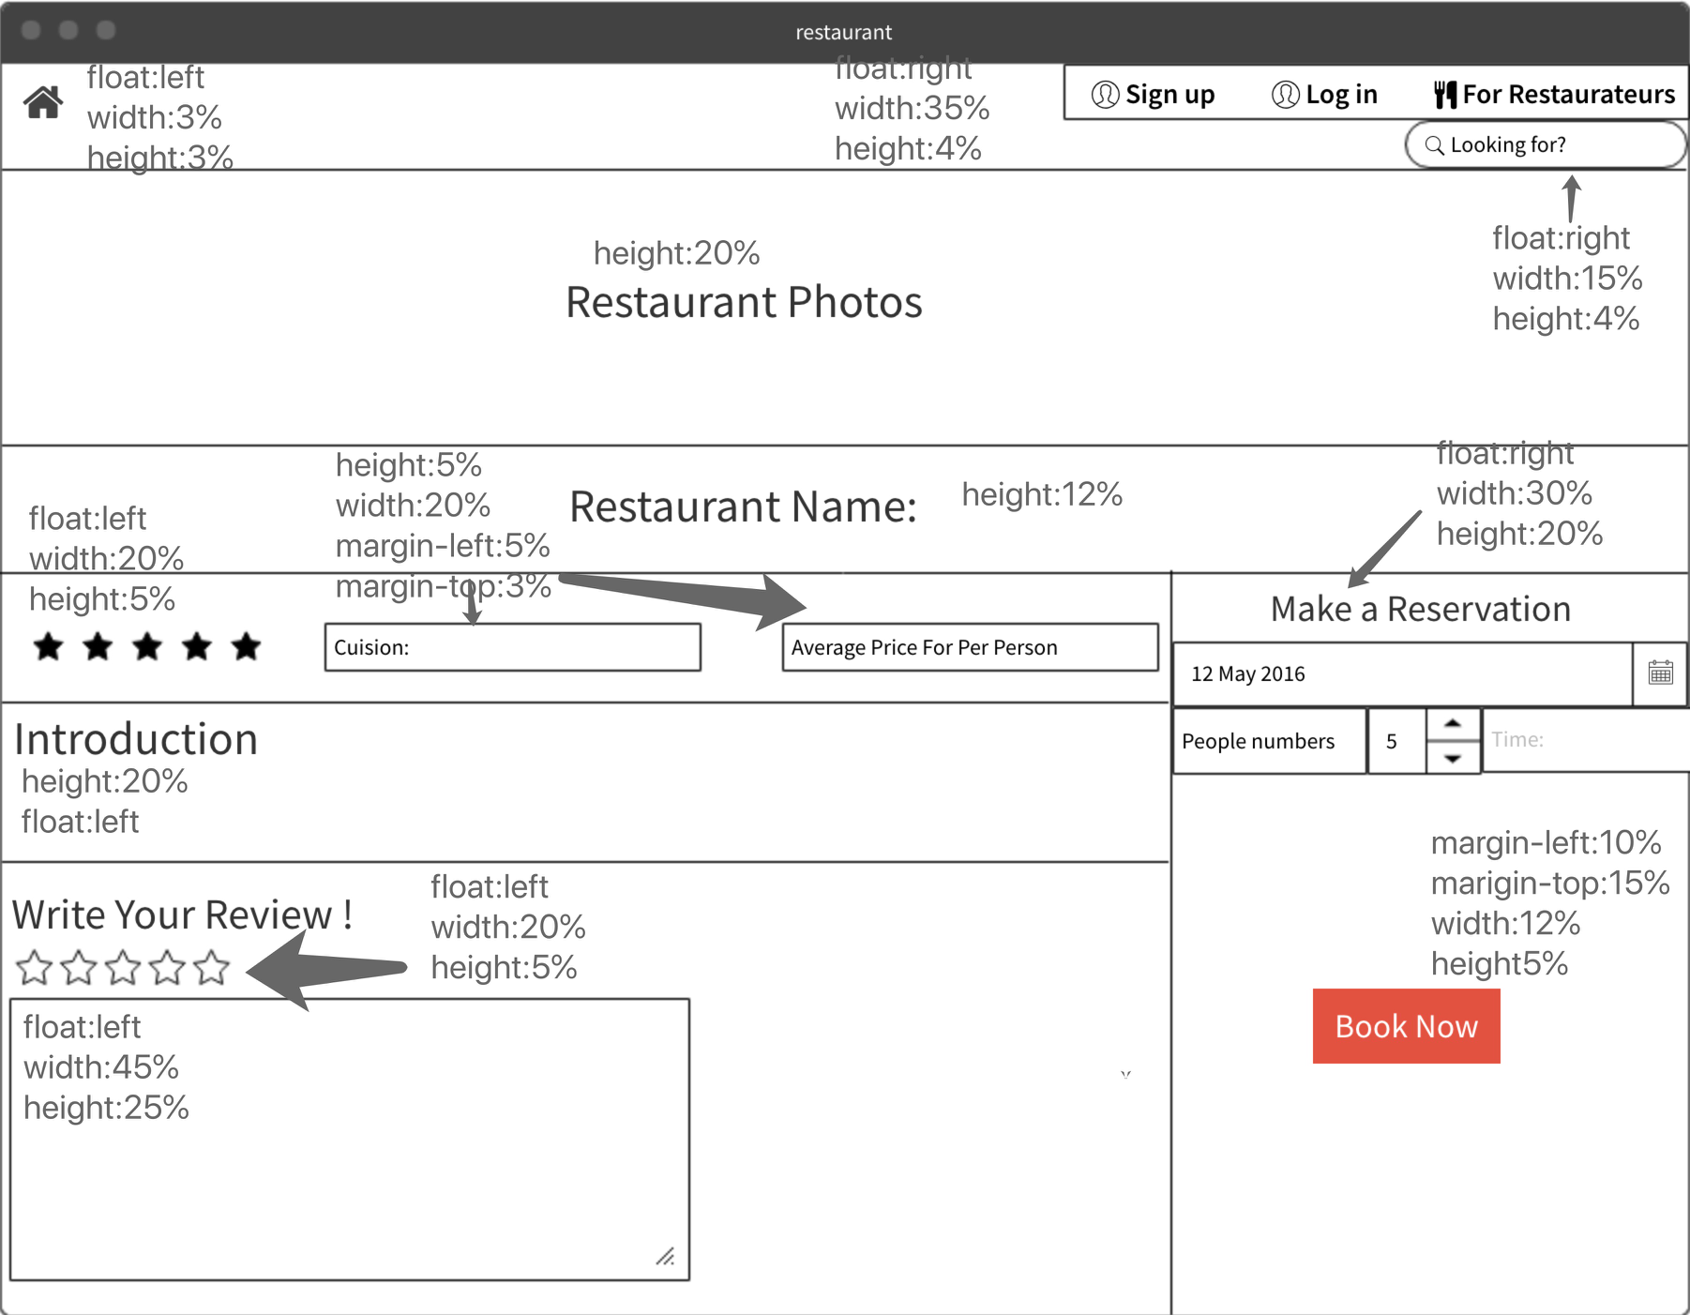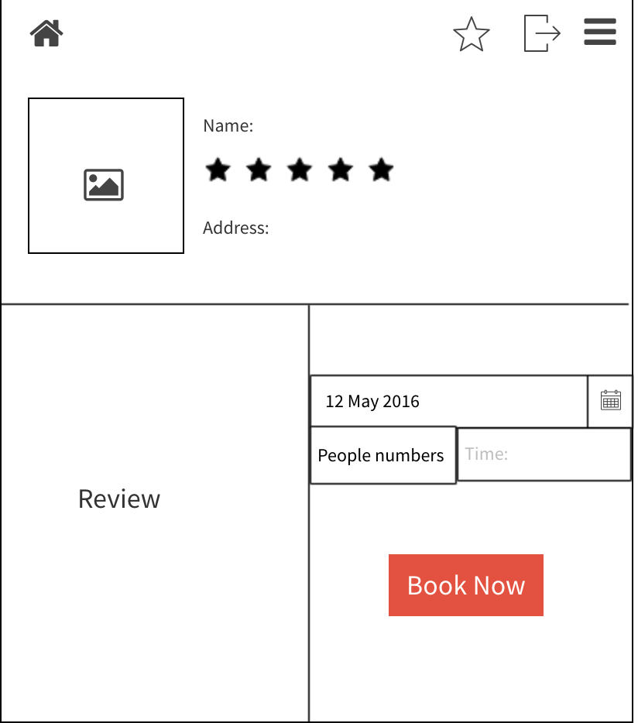

Here’s the design for Restaurant page. The right-top corner is for user and restaurateurs to login and sign up in our webpage. And then we have the basic information and phones at the top of the page. The left-bottom area is review part for customer, and the right part is to make reservations.After click the Book button we will save the restaurant to the user management.(we have comparison of mobile design on the right)

How does it minimise kinematic and cognitive load?

We choose to Keep the page simple – taking out all content from the course that isn’t immediately relevant to the topic at hand will help page to process and retain the information and pass it on to long-term memory.